# Anxiety – Ethovision Protocol

Step 1: Open Ethovision, begin a new project and select your working directory:

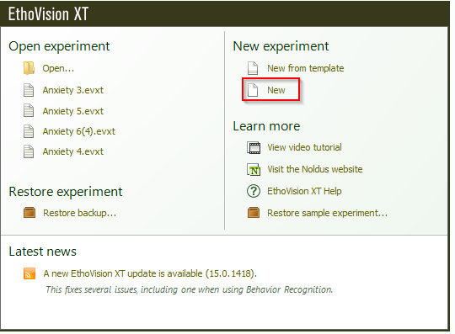

Step 2: Define arena settings. As we are using the tall tanks, we would need to have a total of 6 arenas. To change this setting, go to experiment settings:

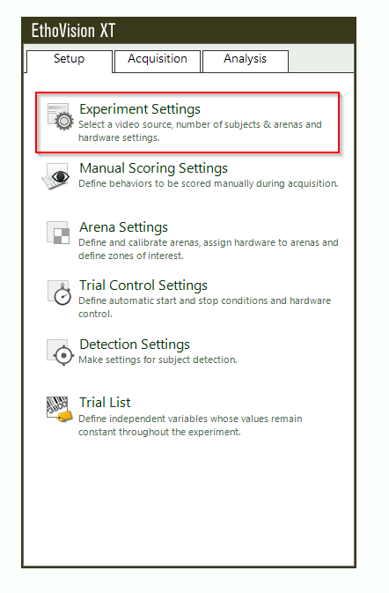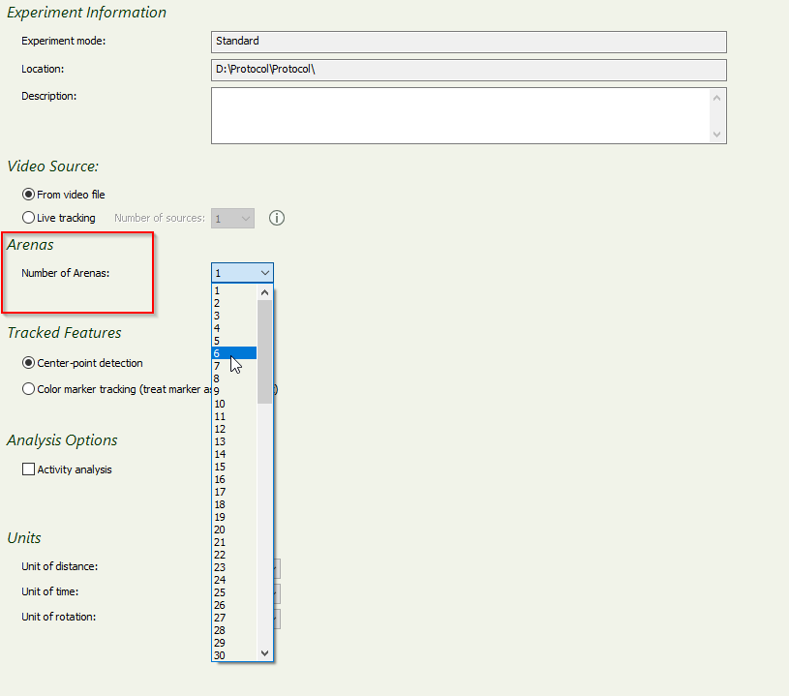

Step 3: Define your arena settings by using a template from one of your trial videos. Click on “Arena settings 1” and you will be prompted to pick a video file, preferably your first trial video. If not prompted, you can always right click the video icon in the panel on the right and press “Grab Background Image”

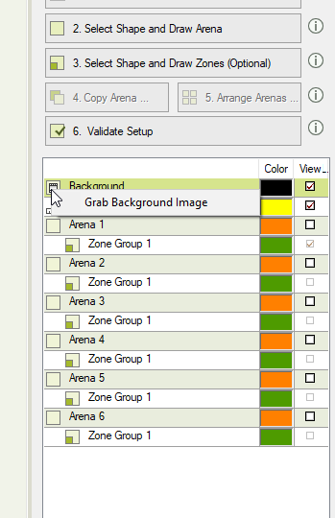

Step 6: Draw arenas in all 6 tanks and ensure they are divided into three zones: Low, Middle and High. Firstly, click on “Arena 1”, select the rectangular tool. Draw a rectangle to match the tank. Be careful to only draw to where the tank was standardized. Ensure the “Arena 1” arrow is pointing in the area. Next, define the zones. Click on “Zone Group 1” and select the grid tool. Draw a rectangle matching and overlapping the arena and then ensure the settings are: 3 rows x 1 column. Once this is done, rename the zones accordingly. The final result should look like:

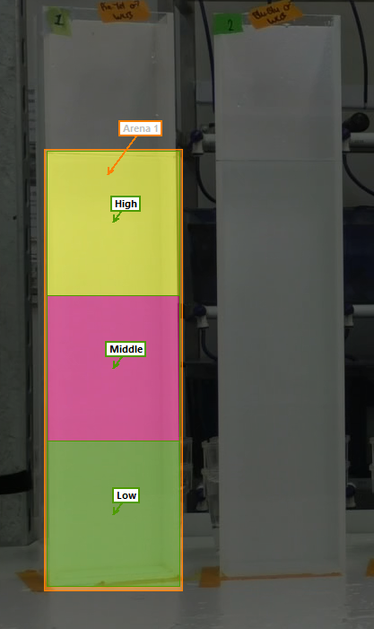

To ensure all other arenas have the same settings, we need to duplicate. However, we can only do this one at a time. For example, to duplicate Arena 1 to Arena 2, we first need to draw the arena as well as the zones divided into three grids (same as we did for Arena 1). Once they are drawn, they will be different colours to Arena 1. At this point, we don’t need to rename, as duplication will fix this. To duplicate, right click on “Arena 1” on the right-hand panel and click on “Duplicate Complete Arena” and then select “Arena 2”.

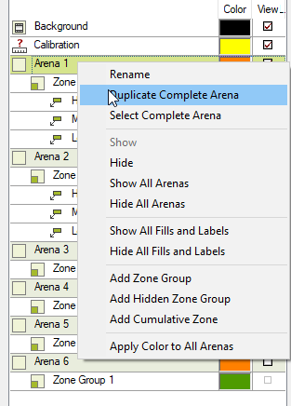

The arena settings will now be duplicated and will look like:

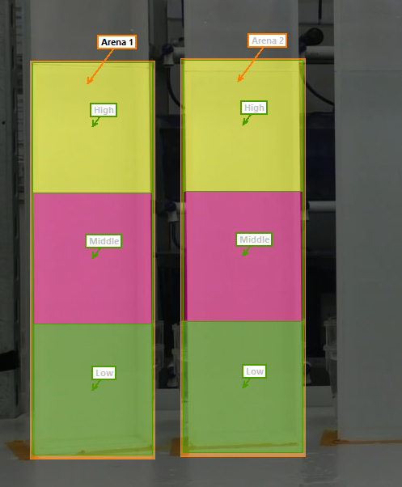

Follow this same procedure of duplication until all arenas are complete. (I.e. Duplicate Arena 1 to Arena 3, 4, 5 and 6).

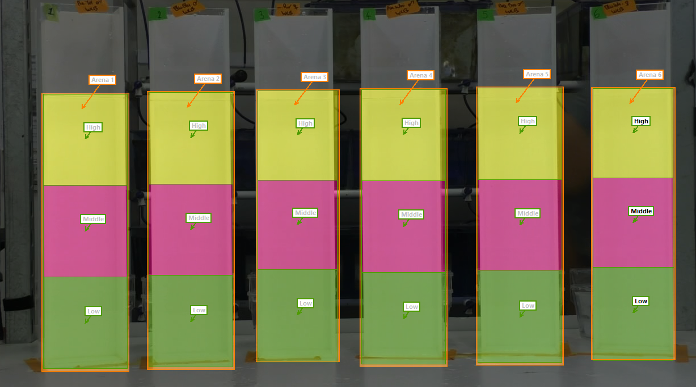

Step 7: Ensure arenas are accurately drawn as possible. To make changes, select the entire contents of the arena by clicking and dragging a window over the whole arena, and then using the corners to make changes to the arena shape:

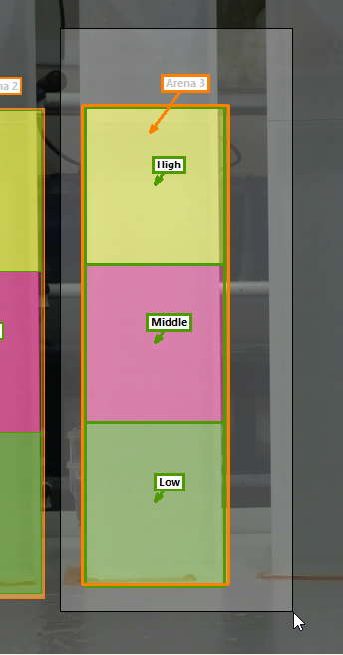

Step 8: Calibrate arenas. All arenas should be calibrated separately. Click on “Draw scale to calibrate” and draw a line the distance of the arena, and define the scale (i.e. for our tanks, it is 46.3cm). Repeat for all tanks.

Step 9: Validate the setup. If settings are not validated, some zones may need touching up (i.e. they may be overlapping or aren’t closed). In this case, Ethovision will show a window describing which zones need fixing. Once settings are validated, we can proceed to the detection settings.

NOTE: If there are instances where the camera was moved, new arena settings must be made. The entire arena settings can be duplicated, and a new background video image template must be used. One can simply select arenas whole and re-draw to match the new background template.

Step 10: Detection settings. Only one needs to be made as it can be used for all videos. Select a video that best matches the overall conditions of your trials (usually the first video or the middle video). Ensure the sample rate is 12.5s and then click on “Automated Setup”. Pick a frame in which all fish are clearly visible, and then draw a small box around the fish. If successful, fish will be highlighted yellow:

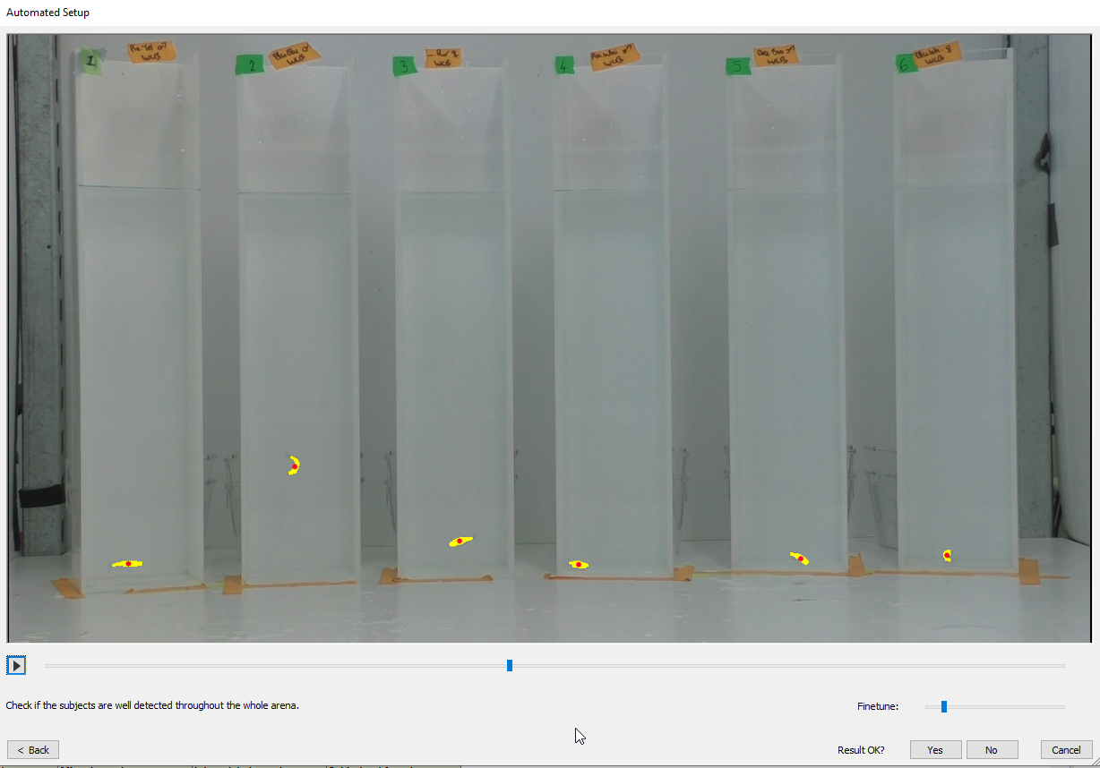

Click on “Yes” and ensure the settings match the following:

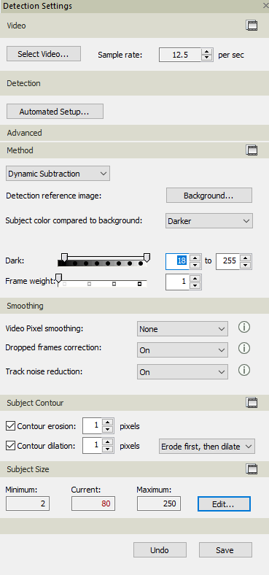

Dark settings can be altered accordingly to match video contrast. Save once completed.

Step 11: Trial control settings. This will define when acquisition starts. For our experiments, we wanted acquisition to start after 40 seconds. To achieve this, settings should look like:

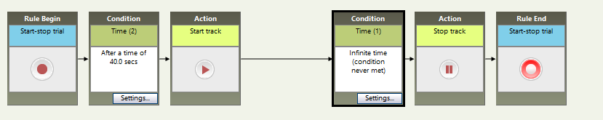

With the “Time” condition being used for starting the track and stopping the track.

Step 12: Trial list. The trial list will dictate which videos match which fish. Since one trial has 6 arenas, every trial added into the trial list will be split into 6 rows for each variable (eg. Fish ID, origin tank etc.). A previous trial list should already be ready with this information. As such, we are essentially copying the content of the trial list into Ethovision. The only extra is matching each trial with the correct video, trial list setting and detection setting. For example, an original trial list will look like:

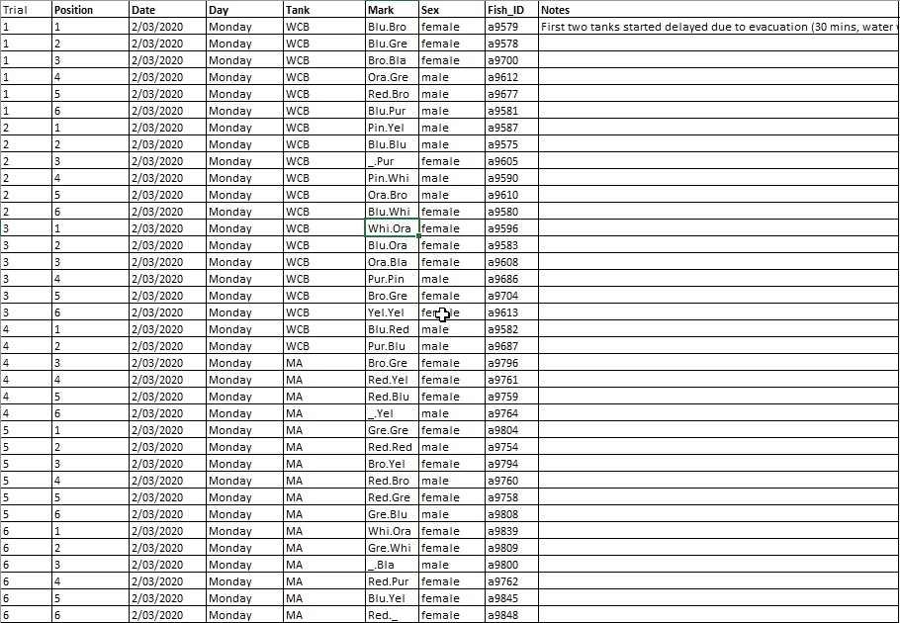

As such, the variables in Ethovision must also match. The result will look like the following:

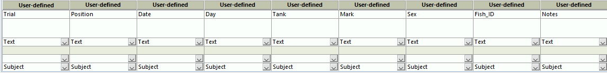

Once this is complete, we must add the correct number of trials. The number of trials will equate to the number of videos. Once the number of trials has been added, we can copy the information from the original spreadsheet into Ethovision.

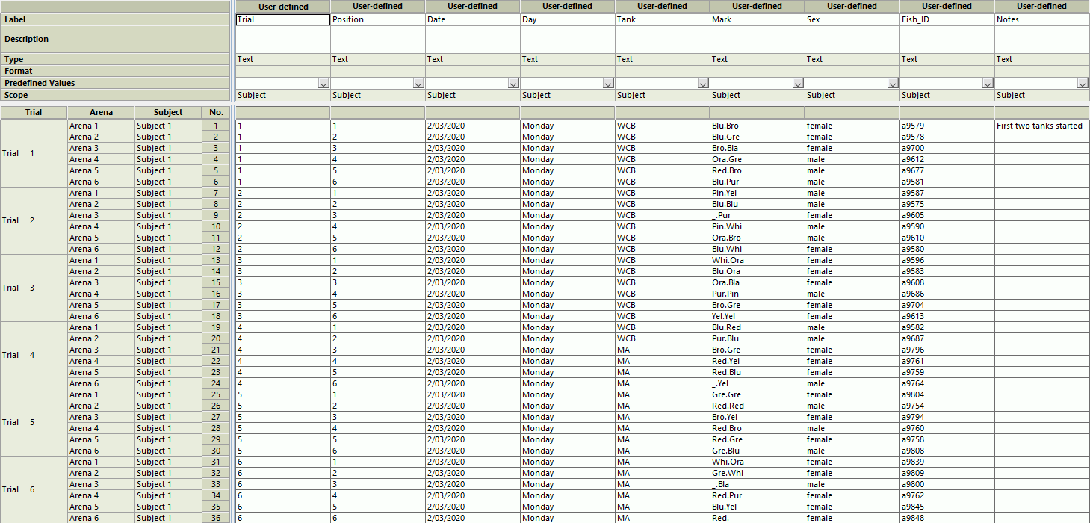

NOTE: Pay attention to any gaps in the original trial sheet. The Ethovision trial list must match the original trial sheet EXACTLY. For example, one trial may have had 5 fish run, with one empty tank. This must also be the case in the Ethovision trial sheet, with that empty arena left as blank. These rows can subsequently be left out for acquisition by setting the acquisition status from “Planned” to “To Skip”.

Once the trial list has been successfully copied over, the correct video file, arena settings, trial control settings and detection settings can be selected for each trial.

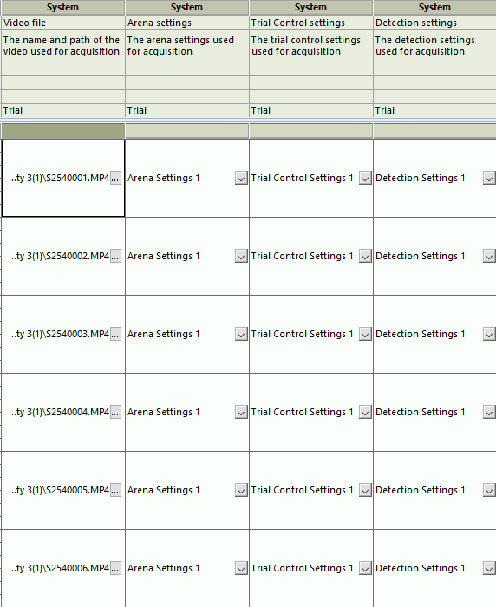

Step 12: Data acquisition. Click on the acquisition tab on the left. To acquire all trials, ensure the selection is set to “Track all planned trials”. Also select “DDS” for faster acquisition although this can be unselected depending on preference. Click on the start button to acquire data.

Step 13: Track editing and re-acquisition of problematic tracks. Once tracks have been acquired, each video must be checked from start to finish to ensure tracks were acquired accurately. The most efficient way is to play the entire video in 16x and observe tracks. Gaps in the tracks will be interpolated if the missing chunk is not too big. In cases where there are large missing chunks, select several time points and accurately place the track back onto the fish. If manual tracking is proving too time-costly, one can delete the tracks for that trial and re-acquire with different arena settings and detection settings. Firstly, to clear a track, go back to the acquisition page and select the option to “Clear and redo a trial”. To create new arena or detection settings specific to the trial that needs to be redone, duplicate the original arena or detection settings and use the trial video that needs to be re-done as the base for the new settings. Then go back to the trial list and select those new settings for re-acquisition.

Step 14: Data profile. Data profiles split the acquired data into relevant components, including time zones or zones of the arena, and organises the data in either blocks, time bins or zones. However, for this experiment, it is a simple setting and all that is required is to ensure data is exported as per trial sheet (we don’t need any unique settings to split the data by time or such).

Step 15: Analysis profile. Here we define the parameters that we want extracted from our acquired tracks. For this experiment, we want to extract the following: total distance, zone duration (low, mid, high), freezing duration, latency to high zone and frequency high zone).

To select these parameters, one must select the following conditions:

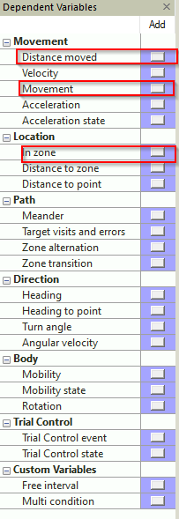

The following settings are required:

For total distance:

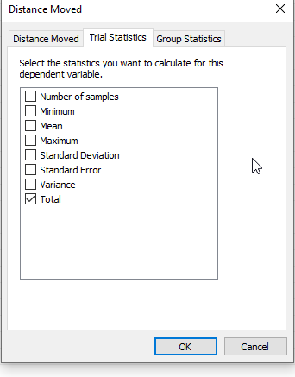

For time spent in zones:

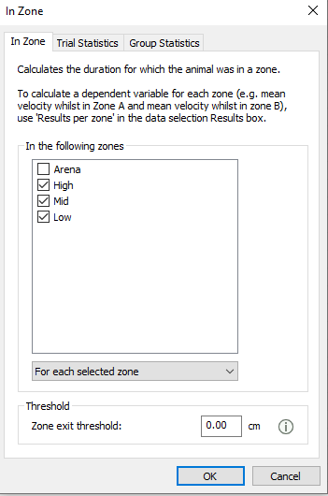

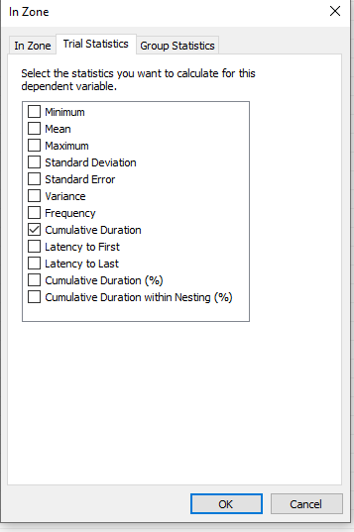

For freezing:

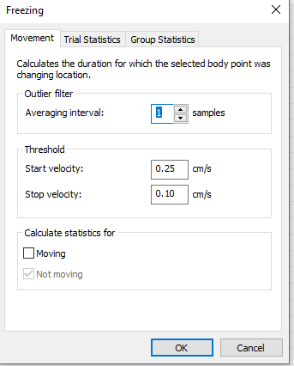

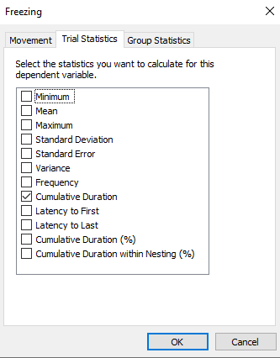

For latency to first enter high zone, select the high zone and select “Latency” in trial statistics; and for frequency of entries, again select the high zone and in trial statistics, select “Frequency”.

Step 16: Calculate and export data. To calculate data, click on “Statistics and charts”, select the correct data profile and click on calculate. Once calculation is done, ensure the layout is fixed and includes all variables in rows. Once this is done, data can now be exported.

NOTE: When acquiring data using trapezoidal tanks, the only changes that need to be made are regarding the arena settings and detection settings. As one must be made for each camera used (Arena settings for camera 1 and camera 2, and detection settings for camera 1 and camera 2).